1. Create Global Data

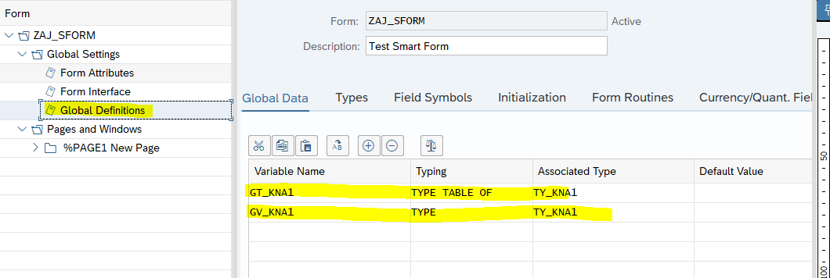

2. create structure for the global data created

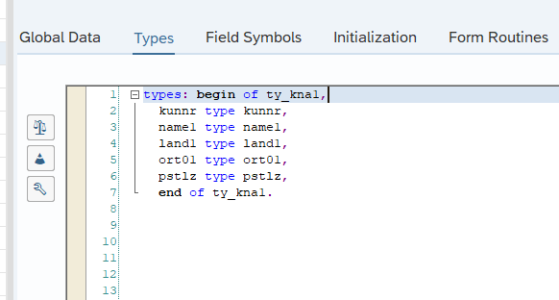

3. Retrieve the data  
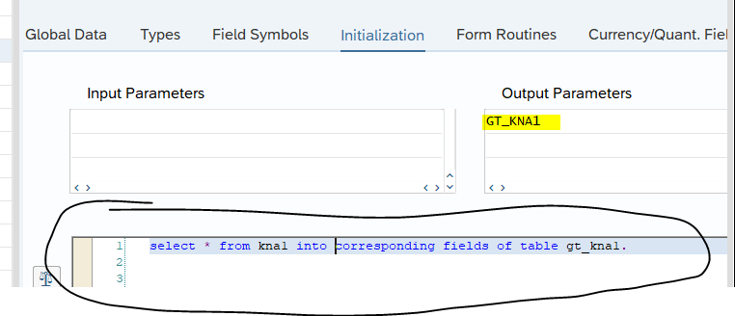

4. Create window table  
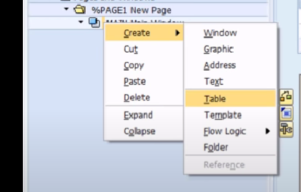

5. create lines for each header field of structure

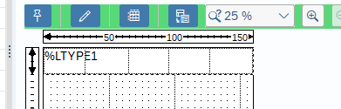

6. Create Table Line

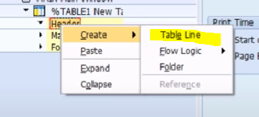

6. this is the created lines in the number 5. Auto generate the cell  
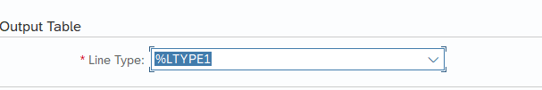  
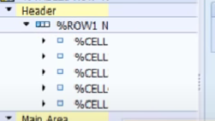

7. Do the same for main area node



8. Create text for each cell

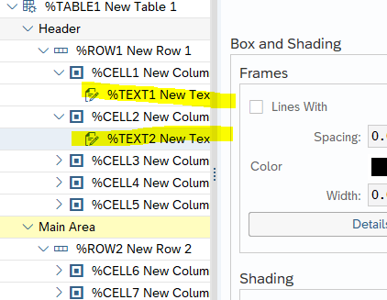

9. Set the column header text in the created text (can name anything)

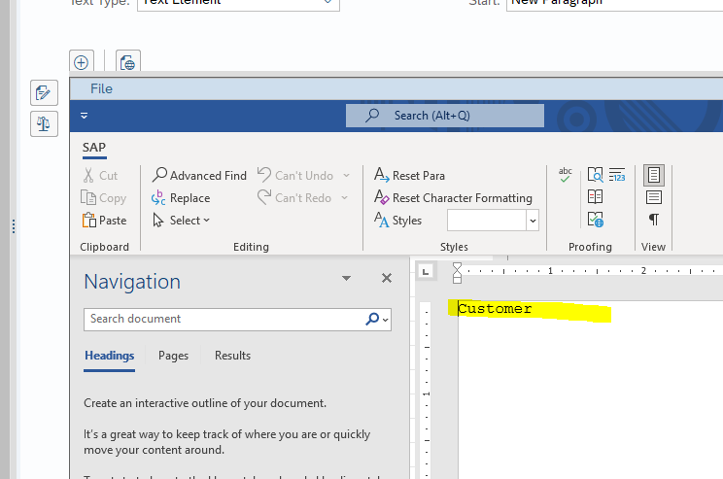

10. Loop at table and input in wa

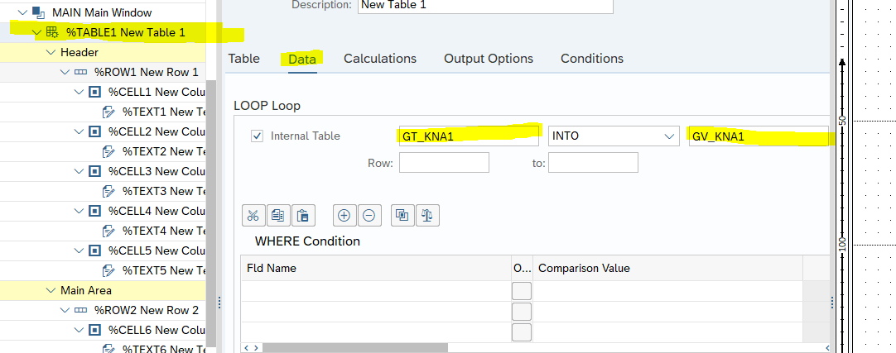

11. For the created text in Main Area. to get the data use & 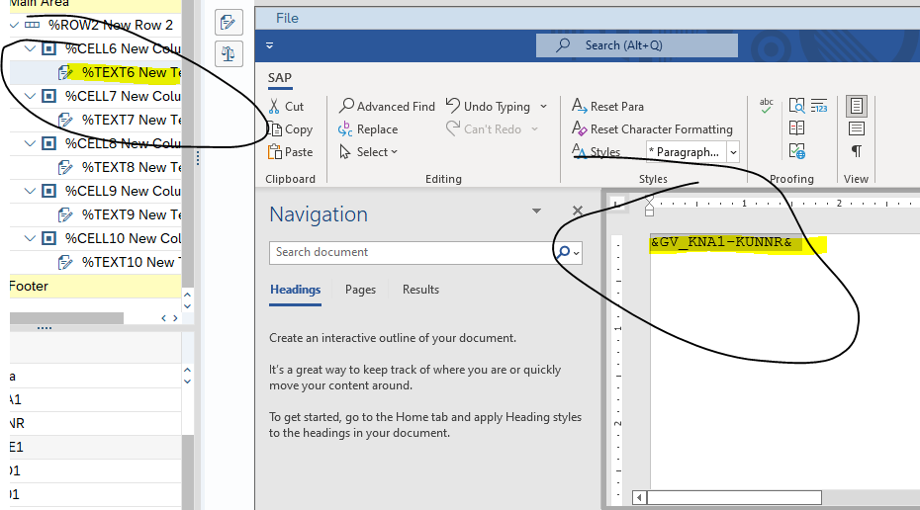

If data are coming from abap program se38

pass the data to parameters

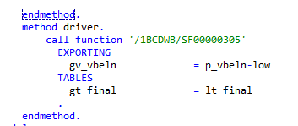

In form interface add the parameters

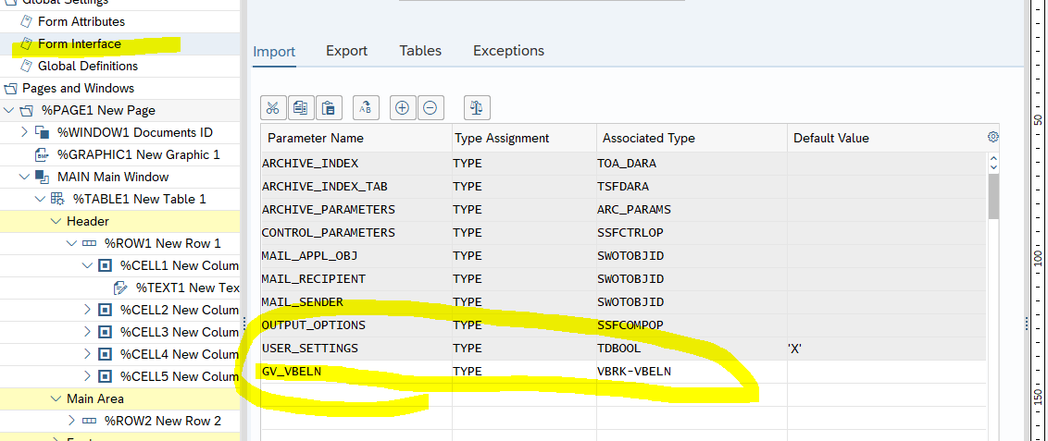

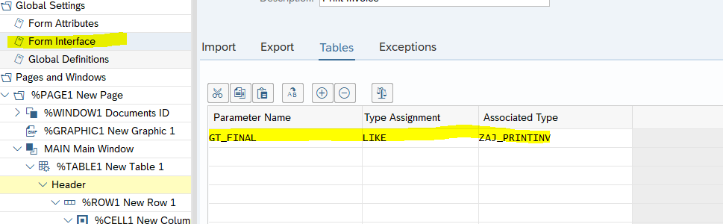

Global Definitions

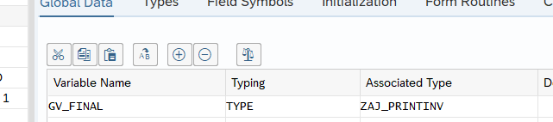

if field is a quantity or need a reference field  
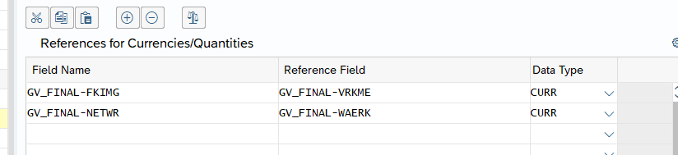

Loop the table

